**A10Wb Index numbers**

Strictly speaking, index numbers do not fall under long-term forecasting. However, it is imperative that we understand them in order to be able to apply some other forecasting methods that we will cover in subsequent chapters. For this reason alone, we have included a section dedicated to index numbers in this Chapter. The simplest way to analyse time series data is to compare values over time with some base value at a point in time. This is essentially the foundation of index number.

Contents

Simple indices 2

Aggregate indices 9

Deflating values 12

**Example 1**

Table 1 contains average annual domestic crude oil prices in the USA from 1980-2017.

|  |  |  |  |
| --- | --- | --- | --- |
| Year | Average price of oil in $/bbl | Year | Average price of oil in $/bbl |
| 1980 | $37.42 | 1999 | $16.56 |
| 1981 | $35.75 | 2000 | $27.39 |
| 1982 | $31.83 | 2001 | $23.00 |
| 1983 | $29.08 | 2002 | $22.81 |
| 1984 | $28.75 | 2003 | $27.69 |
| 1985 | $26.92 | 2004 | $37.66 |
| 1986 | $14.44 | 2005 | $50.04 |
| 1987 | $17.75 | 2006 | $58.30 |
| 1988 | $14.87 | 2007 | $64.20 |
| 1989 | $18.33 | 2008 | $91.48 |
| 1990 | $23.19 | 2009 | $53.48 |
| 1991 | $20.20 | 2010 | $71.21 |
| 1992 | $19.25 | 2011 | $87.04 |
| 1993 | $16.75 | 2012 | $86.46 |
| 1994 | $15.66 | 2013 | $91.17 |
| 1995 | $16.75 | 2014 | $85.60 |
| 1996 | $20.46 | 2015 | $41.85 |
| 1997 | $18.64 | 2016 | $36.34 |
| 1998 | $11.91 | 2017 | $42.74 |

Table 1 Average annual domestic crude oil price in $/bbl.

The price is given in $/bbl. In 1985, for example, the average price of oil was $26.92. In 2007, the same oil was priced at $64.20. The question we might be interested in exploring is: by how much has the 2007 nominal price changed when compared to the one from 1985? To answer this question, we need to use index numbers.

**Index numbers** measure the change, typically expressed in percentages. To answer the question we introduced, all we have to do is to divide the price of oil from 2007 with the one from 1985 and multiply it by 100:

Index change = 

In other words, if the price in 1985 is treated as a **base index period** (which is equal to 100); then the price index in 2007 is 138% higher than the one in 1985, i.e. 238 - 100=138. A general formula for calculating a **simple index** It at any point in time is:

 (1)

Where yt is the value for the year for which index is calculated and y0 is the value for the base year.

### Simple indices

Applying equation (1) to calculate the index in 2007 gives



**Example 2**

Figure 1 illustrates the Excel calculation procedure to calculate the required indices for the average annual oil price.

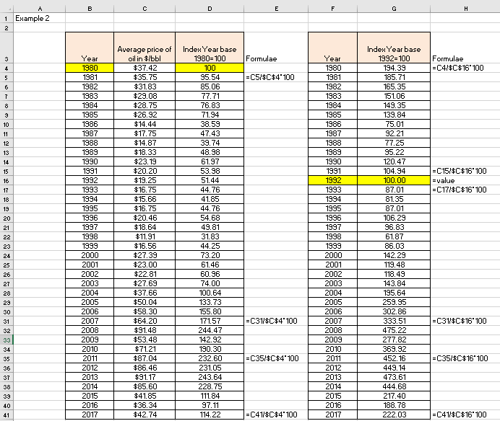

Figure 1

**Excel solution**

Year Cells B4:B41 Values

Average price Cell C4:C41 Values

Index base 1980 = Cell D4 Value (=100)

Cell D5 Formula:=C5/$C$4*100

Copy formula D5:D41

Year Cells F4:F41 Values

Index base 1992 = Cell G4 Formula:=C4/$C$16*100

Copy formula G5:G15

Cell G16 Value (=100)

Cell G17 Formula:=C17/$C$16*100

Copy formula G18:G41

For the first index series (see column D): The price of oil in the year 2005, for example, in nominal dollars was $50.04 and in 1980 it was $37.42. The difference is $12.62, which is 33.73% of the initial price in 1980. In other words, when compared to 1980, the price of oil in 2005 has gone up by 33.73% in nominal dollars. The index confirms the same, i.e. the index in 2005 is 133.73 and in 1980 it is 100, hence 133.73-100=33.73%.

For the second index series (see column G): The price of oil in the year 1992 was $19.25 and in 1999, for example, it was $16.56. In nominal terms, the price has gone down by $2.69, which is 13.97%. As the index for 1992 is 100 and the index for 1999 is 86.03, this confirms our calculation (100-86.03=13.97), i.e. the price of oil in 1999 was 13.97% lower than the price of oil in 1992.

Let’s say that we want to know by how much was the price of oil higher in the year 2000 when compared to year 1990. Using the first series of indices (column D), the one where 1980 is the base year, this is calculated as:



We can do the same for the second series of indices (column G), the one where 1992 is the base year:



Clearly, we are getting the same answer, regardless what the base year is for indices.

To convert indices from one base to another is also easily achieved.

**Example W9.4**

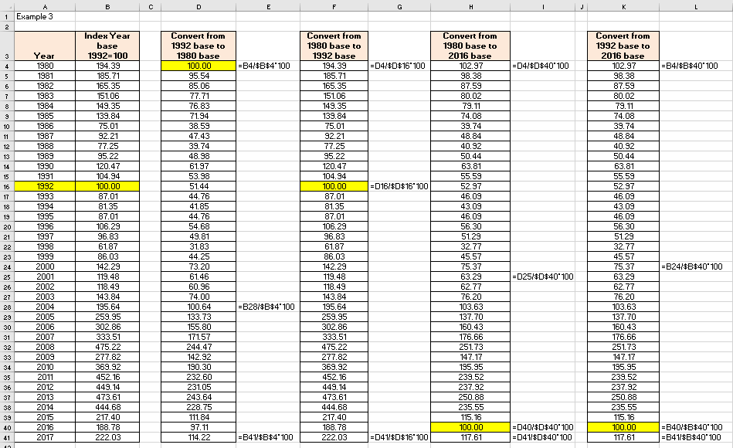

Figure 2

**Excel solution**

Index 1992=100 Cells B4:B41 Values

Convert from 1992 to 1980 Cell D4 Formula: = B4/$B$4*100

Copy formula D5:D41

Convert from 1980 to 1992 Cell F4 Formula: = D4/$D$16*100

Copy formula F5:F41

Convert from 1980 to 2016 Cell H4 Formula: = D4/$D$40*100

Copy formula H5:H41

Convert from 1992 to 2016 Cell K4 Formula: = B4/$B$40*100

Copy formula K5:K41

We use the index data from column G in Figure 1 to demonstrate how to convert indices from one base to another. This column was copied into Figure 2 as column B. Imagine that you have downloaded this column B in Figure 2 from the internet, which are the indices for 1992=100, but you really need indices where 1980=100 is the base. How do you convert 1992=100 based indices into 1980=100 based indices? As the column D in Figure 2 shows, you divide every index value in column B with the index value of the new base (in our case with cell B4, because this is 1980 and will be a new base).

To demonstrate the inverse action, we also created column F in Figure 2 where from the base 1992=100, we converted indices back to 1980=100. As we can see the values in column F are identical to those from column B, as expected.

In addition, we demonstrated conversion to the base 2016=100, as an example, from two different previous bases (one from 1980=100 and the other one 1992=100). We can see that regardless what the origin list of indices is, we get the same values to the new base (columns H and K).

The above examples confirm that, just like with conversion of observation values into indices in equation (2), the same rule applies to conversion of the indices from one base to another:

 (2)

Rather than having a time series of indices on a fixed basis, i.e. starting from one particular year that is equal to 100, we can have also indices on a year-to-year basis. This effectively means that every previous year becomes the base year, equivalent to 100. These are called chain-based index numbers, or simply, chain indices.

**Example 4**

Figure 3 illustrates the calculation procedure to calculate the average oil price and the chain-based index values for oil prices.

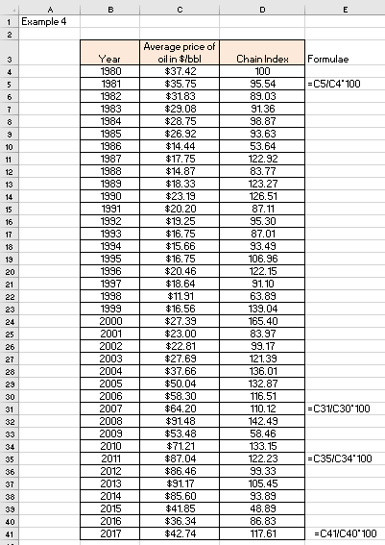

Figure 3

**Excel solution**

Year Cells B4:B41 Values

Average price Cell C4:C41 Values

Index base 1980 = Cell D4 Value (=100)

Cell D5 Formula: =C5/C4*100

Copy formula D6:D41

Every preceding year is treated as if the value was 100. This means that the average oil price in 1985, for example, has dropped when compared to the previous year by 6.37% (100-93.63=6.37) and the price in 2013, for example, has grown by 5.45% in comparison with the previous year.

One practical task that we might need to do from time to time, is to convert the chain indices into the fixed based indices.

**Example 5**

We took the same chain indices from the previous example and put them in column B of this example. Column C transforms chain indices into a fixed base indices, where base is 1980=100.

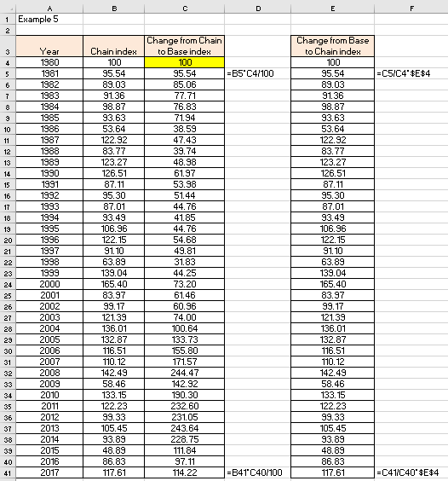

Figure 4

**Excel solution**

Year Cells A4:A41 Values

Chain index Cells B4:B41 Values

Convert from Chain index

to Base index 1980=100 Cell C4 100

Cell C5 Formula: =B5*C4/100

Copy formula C6:C41

Convert from Base index

to chain index Cell E4 100

Cell E5 Formula: =C5/C4*$E$4

Copy formula E6:E41

The conversion of the fixed based indices into chain indices, is done in column E. As expected, the values we got in column E are identical to those from column C.

In the previous example, the chain index started in 1980 and we converted these indices into a fixed base indices, where the base year was also 1980. Can we convert chain indices into the base year indices, but where the base year is not the same as the beginning of the chain indices?

**Example 6**

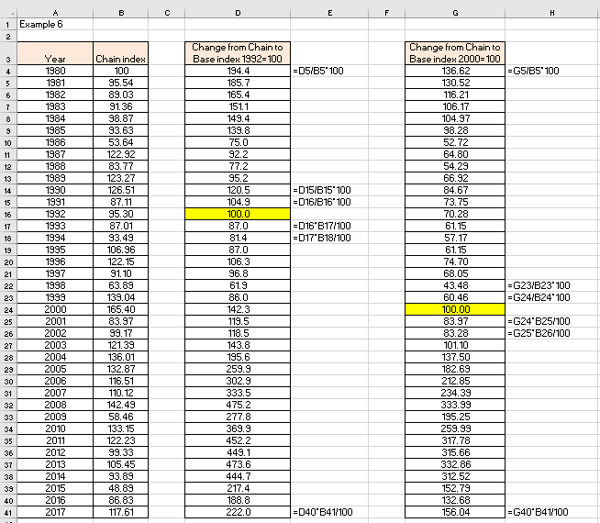

Figure 5

**Excel solution**

Year Cells A4:A41 Values

Chain index Cells B4:B41 Values

Factor Cells D4:D41 Values

Convert from Chain index Cell D4 Formula: =D5/B5*100

to Base index 1992=100 Copy formula D5:D15

Cell D16 Value =100

Cell D17 Formula: =D16*B17/100

Copy formula D18:D41

Convert from Chain index Cell G4 Formula: =G5/B5*100

to Base index 2000=100 Copy formula G5:G23

Cell G24 Value =100

Cell G25 Formula: =G24*B25/100

Copy formula G26:G41

Column B contains the same indices from Example 5, which are the chain indices for the average price of oil in $/bbl in the US from 1980 until 2017. Column D converts the chain indices from column B into fixed base indices, where the base is defined as 1992 (1992=0). Compare them with the values in column F, in Example 2. They are identical, as expected. We have also done a conversion to base indices, where the base year is 2000 (2000=0). These values are placed in column G.

How do we interpret the values in cells D32 and G32, for example? Both cells refer to year 2008. Cell D32 has the value of 475.2 and cell G32 has the value of 333.99. Because the bases are different, the value in D32 means that the price of oil has gone up by 375.2% since 1992 and the value in cell G32 means that the price of oil has gone up by 233.99% since year 2000. The actual price in this year 2008 was $91.48 and the prices for 1992 and 2000 were $19.25 and $27.39. Do the maths and you will see that the above numbers are spot on.

Now we understand both the fixed base or chain indices, we can move to some more complicated indicators, such as aggregate price indices.

### Aggregate indices

In our previous examples we used US prices of oil, so let’s stay with the US economy numbers. One of the best-known aggregate price indices, for example, is the US Consumer Price Index (CPI). In the US this index is calculated every year (in fact it is calculated every month) by the US Bureau of Labor Statistics and it is a primary measure of changes in cost of living in the US. In fact, CPI measures changes in the cost of a typical market basket of goods and services. It is composed of housing prices, transportation, food, energy, medical care, etc. What is important to understand is that CPI is a measure of inflation. Inflation is effectively calculated as the percentage change in the CPI from one year to the next (or one month to the next). Identical aggregate indices exist in every country, including the UK, though the basket of goods and services might be slightly different.

As CPI measures changes from one period to the next, this means that CPI is effectively a chain index.

**Example 7**

Figure 6 shows the value of US CPI from 1980-2017 (columns A:D) and the fixed base indices (columns F:I), calculated on the basis of year 2000, i.e. year 2000=100 (we picked this year arbitrarily).

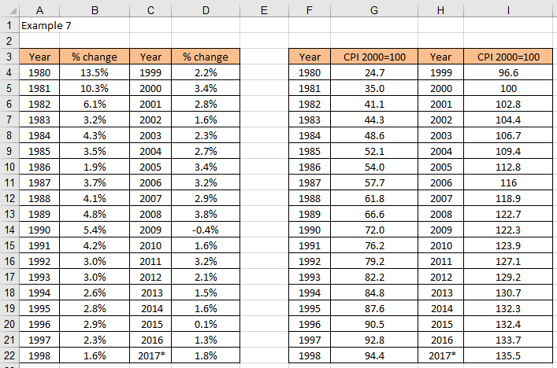

Figure 6

The table in columns A:D contains the annual percentage change in the US CPI, which is effectively the official rate of inflation in the US. We know by now how to calculate the table in columns F:I from the values given in the table A:D. However, let’s throw in another challenge. What if you found on the web just the table as in columns F:I and you would really like to know the actual annual percentages?

To calculate the actual value of CPI for year 2016, for example, when compared to the previous year, all we have to do is subtract the values for the two years:

$\text{CP}{\text{I}}_{\text{2016}}\text{ = }{\text{I}}_{\text{2016}} \text{- }{\text{I}}_{\text{2015}}\text{ = 133.7 - 132.4 = 1.3}$

The value in Figure W9.10 in column D for 2016 confirms this number.

Let’s assume again that you’ve downloaded from the web the numbers in column B and D from Figure W9.10. These numbers represent CPI changes from year to year. Let’s also assume that you wanted to convert them to fixed indices, but based on year 2000 (2000=100). Depending how the numbers are presented, this conversion could take several forms. Example W9.9 demonstrates.

**Example 8**

Figure 7 represents the excel solution.

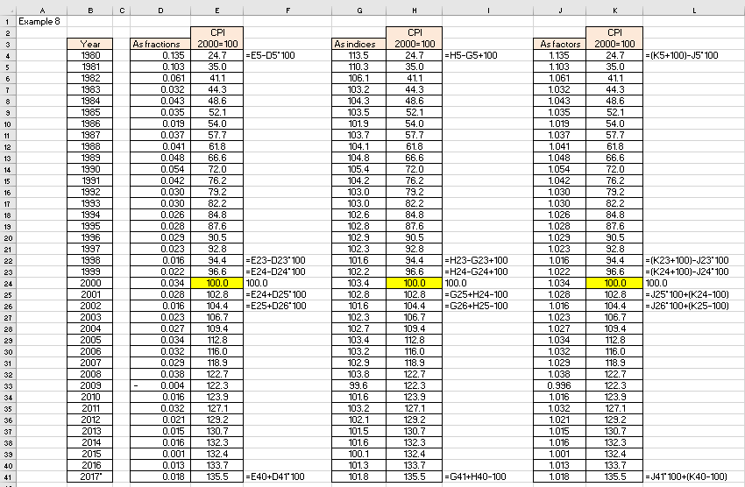

Figure 7

**Excel solution**

Year Cells B4:B41 Values

CPI values as fractions Cells D4:D41 Values

CPI indices 2000=100 Cells E4:E23 Formula: =E5-D5*100

Cell E24 Value =100

Cells E25:E41 Formula: =E24+D25*100

CPI values as indices Cells G4:G41 Values

CPI indices 2000=100 Cells H4:H23 Formula: =H5-G5+100

Cell H24 Value =100

Cells H25:H41 Formula: =G25+H24-100

CPI values as factors Cells J4:J41 Values

CPI indices 2000=100 Cells K4:K23 Formula: =(K5+100)-J5*100

Cell K24 Value =100

Cells K25:K41 Formula: =J25*100+(K24-100)

Depending on how the indices are written in Excel table (for example: 104.6, or 0.046, or 1.046), different formulae will apply. We formatted the same set of indices differently in columns D, G and J. Also note that different formulae are used below the base index =100 and above the base index. In our case, the base index is in row 24. Check the formulae in columns E, H and K below and above this row.

CPI has one very important property: it can be used as a price deflator. We can use CPI to convert (or **deflate**, hence the word deflator) prices from any year into the so called constant prices. This is sometimes called converting actual (or nominal) dollars (or dollars of the day) into real (or constant) dollars, i.e. dollars free from inflation.

### Deflating values

**Example 9**

Let’s take the example of oil prices as before. Figure 8 illustrates the Excel solution. Column B repeats the average annual price of the US crude oil in $/bbl. These values are given in current dollars, i.e. the value of dollar in every given year. Column C shows the values of the CPI index for every year, given on the basis of year 2000=100.

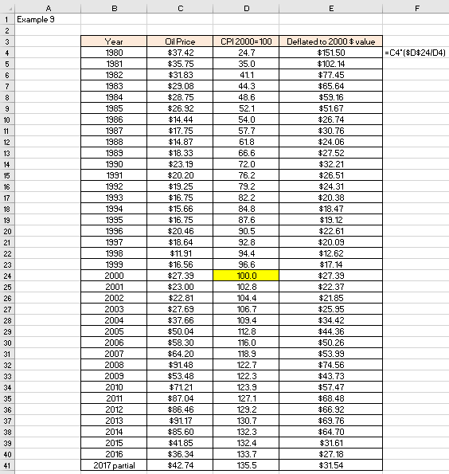

Figure 8 Oil prices deflated with CPI

**Excel solution**

Year Cells B4:B41 Values

Oil price Cells C4:C41 Values

CPI Cells D4:D41 Values

Deflated Value = Cell E4 Formula:=C4*($D$24/D4)

Copy formula down E5:E41

To convert the prices of oil into a constant value, we need to deflate them. In our example we can deflate them by multiplying annual prices with their corresponding CPI that is divided by the base year, i.e. year 2000, as per our example: Price at time A = Price at time B x (CPI at time A / CPI at time B). In more general sense, this formula is:

 (3)

If you look at Figure 8, you will see that the price of oil in 1980 was $37.42 and in 2016 $36.34. Nominally, there is virtually no difference in price (37.42-36.34=1.08) over 36 years. In fact, 2016 price is significantly lower than the one from 1980. However, when expressed in constant dollar value for year 2000, then 1980 price becomes $151.50 and 2016 price, for example, becomes $27.18. Clearly, in terms of constant dollar, on the basis of its value in the year 2000, the price of oil in 2016 is similar to what it was in the year 2000, whilst the price of oil in 1980 was some 5.5 times higher than it was in 2000 or in 2016 ($151.50/$27.00≈5.5). This technique puts the perception of prices in a different perspective.

**Example 11.10**

Using the previously described technique for converting indices from one base to another, if we wanted to calculate the price of oil on the basis of constant value of US Dollar for the year 2016, for example, the calculation is shown in Figure 9.

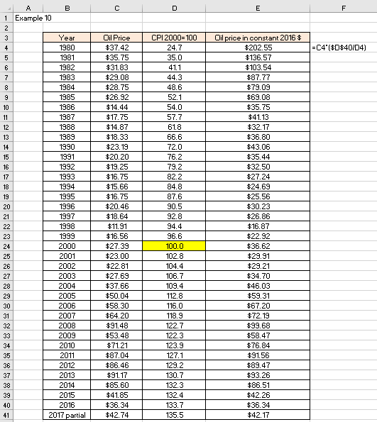

Figure 9 Deflated oil prices with CPI

**Excel solution**

Year Cells B4:B41 Values

Oil price Cells C4:C41 Values

CPI Cells D4:D41 Values

Deflated Value = Cell E4 Formula:=C4*($D$40/D4)

Copy formula down E5:E41

In column D in Figure 9 we used the fixed indices for 2000=100 that we already had from before. From this column we calculated new values based on constant dollar value for 2016 (column E). The above calculation helps us with simple questions such as: By how much in real terms is the price of oil in 2016 of $36.34 higher than the price of oil of $37.42 in 1980? Or, you can translate this into a different question: how much is $37.42 from 1980 worth in 2016 terms? This is calculated as: Adjusted Price = Old price*(CPI for 2007/CPI for 1980). In more general terms:

 (4)

Given that 2016 price of oil is $36.34, this means that in 1980 the price of oil was equivalent to $202.55 in 2016 dollars. Using the constant value of dollars in 2016, the price of oil in 1980 was in real terms $166.21 (202.55-36.34=166.21) dollars more than the 2016 price of oil of $36.34.